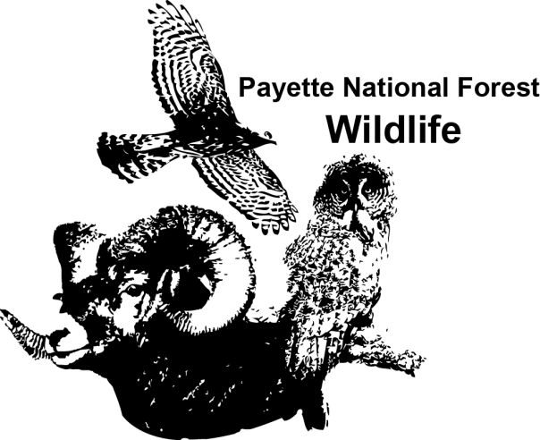
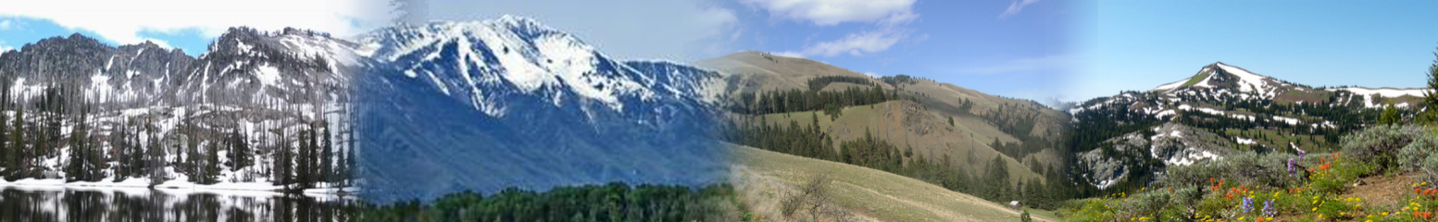
OUTREACH NOTICE

Fuels Technician
GS-462-07
McCall, ID

The Payette National Forest is seeking candidates to fill a GS-0462-07, Fuels Technician position. This is a DETAIL opportunity and maybe filled as a temporary promotion. The duty location for this position is in the community of McCall, Idaho. The requirements for this position are the fire qualifications of FFT1 and ICT5. Interested applicants should contact Justin Pappani at 208-634-0623 or jpappani@fs.fed.us by close of business June 9, 2016.

This position serves as a Fuels Technician on the Krassel Ranger District; East Zone of the Payette National Forest. This position works for the East Zone Fuels Specialist and supports the West and Central Zone Fuels organizations as needed and will not exceed 120 days.

ABOUT THE JOB
Specific tasks for the position include:
- Minimum qualificasons fo the position are the fire qualifications of FFT1 and ICT5
- Developing burn plans for implementation on the East Zone of the Payette National Forest
- Conduct pre and post burn monitoring of prescribed burns
- Conducts field reconnaissance and data collection for future projects using established protocol.
- Conducts and coordinates fuel sampling for the East Zone; reports results to Payette Intelligence Dispatcher, Zone Fire staff, etc.
- Ensure all fuels equipment is in working order and has required maintenance.
- Gain familiarity with predicted future prescribed burns to determine potential logistical, operational, and planning needs.
- Provides WFDSS and GIS support for fire program
- Operational fire support as qualifications allow
- Housing, perdiem (except for field perdiem), flexible schedules, telework, GOV or government time for communiting not likely available. Please inquire.

Specific questions regarding this position can be addressed to Justin Pappani; Fire Management Specialist at 208.634.0623 or by e-mail at jpappani@fs.fed.us

ABOUT THE PAYETTE NATIONAL FOREST
The Payette National Forest contains some of Idaho’s most beautiful and diverse country. Located north of Boise in west-central Idaho, the 2.3 million acre forest extends 100 miles west to east, from Hells Canyon to the Middle Fork of the Salmon River in the Frank Church River of No Return Wilderness. The forest stretches 70 miles between the Main Salmon River to the north and the Weiser River to the south. There are five Ranger Districts, approximately 200 permanent employees, and over 150 temporary seasonal employees during the summer field season. The current Forest priorities are:
- Landscape Restoration focusing on working with collaborative groups to accomplish landscape-scale restoration in the Weiser River and Little Salmon watersheds, which will improve watershed function, habitat for wildlife, recreational opportunities, and reduce hazardous fuels, as well as provide local employment through stewardship contracting.
- Recreation Management supporting developed and dispersed recreation opportunities during both summer and winter seasons across the Forest, stewardship of the Payette’s portion of the Frank Church River of No Return Wilderness, and providing outstanding public service.
- Rangeland Management managing for sustainable rangeland resources such as soil, water and native vegetation while administering livestock grazing permits and monitoring to maintain separation between domestic sheep and bighorn sheep during the grazing season.
- Minerals Management of significant minerals projects and the numerous smaller minerals development projects.
- Wildland Fire Preparedness including training and preparedness to manage wildland fire incidents on the Forest and across the country.
We hope you will consider the Payette National Forest as your future home for career and recreation. More information on the Payette National Forest is available at: www.fs.usda.gov/payette.
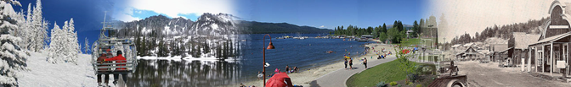

MCCALL

McCall, located in Valley County, lies 100 miles north of Boise on State Highway 55. Sitting at 5,000 feet, it occupies the south shore of beautiful Payette Lake. The population swells from 2,700 to 10-20,000 in the summer during the peak of tourist season and in the winter during the annual Winter Carnival celebration. Total snowfall is over 10 feet, allowing McCall to boast some of the best winter recreation in the state, with snowmobiling, sledding, Nordic and downhill skiing. Brundage and Tamarack Resorts are within a short drive. Summer is shorter than at lower elevations but is ideal, with daytime temperatures in the 70-80s, and a few days in the 90s. Payette Lake provides plenty of swimming, boating, and fishing opportunities in the summer; a state park and adjacent Forest lands provide ample hiking, running and biking trails. Sunshine is common in all seasons. Access to the expansive and remote Frank Church-River of No Return Wilderness Area and Hells Canyon National Recreation Area and Wilderness are located nearby.
McCall is a full-service community that fills most needs. It has a regional hospital, an integrative health clinic, dentists, chiropractors, and optometrists. McCall also has several service stations, two grocery stores, motels, banks, lumber yards, a variety of restaurants, coffee shops, a wide variety of shopping, daycare centers (including a Forest-sponsored daycare), a public and a private golf course and an airport. Numerous churches are located in the surrounding area.
The community has an excellent grade school, new middle school, a high school that serves both Donnelly and McCall, and an alternative school. Numerous extra-curricular activities and electives are available. There is a strong winter sports program, with both downhill and Nordic after school ski programs. For more information: http://www.mdsd.org/
The Payette National Forest Supervisor’s Office, McCall and Krassel Ranger District offices, Tanker Base, Payette Dispatch, McCall Smokejumper Base, and McCall Helibase are all located in McCall. Government housing is available on a very limited basis. Average housing cost is in the $250,000 to $350,000 range. Rentals are available from $900 to $1,200/month.
For more information about living the dream in McCall, visit these websites:

McCall Public Schools St. Luke’s Hospital McCall
McCall Chamber of Commerce City of McCall
Ponderosa State Park The Star News
Brundage Mountain Resort Little Ski Hill and Bear Basin Nordic Center
McCall Area Snowmobilers Manchester Ice and Event Center
McCall Golf Club McCall Wikipedia page
McCall weather averages

Communities close to McCall include New Meadows and Council to the southwest, Donnelly and Cascade to the south, and Riggins to the north. All are within an hour’s drive of McCall.

Interested applicants should contact Justin Pappani, Payette National Forest Krassel Ranger District at

CONTACT
208-634-0623 or jpappani@fs.fed.us.

For information about how to apply for a federal job, the salary, or job series, visit the
US Office of Personnel Management website.

