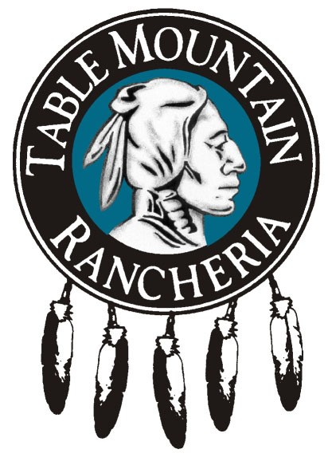

Environmental Director

Table Mountain Rancheria, in Friant, California is located near Fresno, California. We have an immediate opportunity for an experienced Environmental Director looking for full-time work with excellent benefits including Medical, Dental, Vision, 401(k), Paid Time Off, Holiday Pay and Cafeteria Plan. This is a salaried position, pay will be based experience. Open until filled.

This is an on-site position; telecommuting is not available. Email resumes to jobs@tmr.org , mail to TMR, PO Box 410, Friant, CA, 93626, and Attn: Human Resources or Fax to (559)822-4392. Candidates meeting the minimum requirements will be contacted and asked to complete an employment application. The final candidate will be required to pass an extensive background check. Relocation benefits are not offered for this position.

Job Summary: The Environmental Director has the primary responsibility for coordination, administration and management of the environmental decisions; including management of the Tribe’s Environmental grants of which the primary focus relates to a broad range of environmental issues; hazardous and solid waste management, emergency preparedness planning, air and water quality. Conducts research studies to develop theories or methods of abating or controlling sources of environmental pollution by performing the following duties:

Essential Duties and Responsibilities: Other duties may be assigned.

Determine data collection methods to be employed in research projects and surveys.

Plans and develops research models.

Develops updates and enforces Tribal Environmental Ordinances.

Conducts, researches, collects, and organizes environmental data.

Identifies and analyzes sources of pollution to determine their effects.

Collects and synthesizes data derived from pollution emission measurements, atmospheric monitoring, meteorological information, and soil or water samples.

Interpret and report assessments to Tribal Council.

Advise the Tribal Council in prioritizing environmental needs for the Rancheria.

Conducts research and assists with efforts for seeking additional sources of food for future environmental projects for writing grants.

Development of the department policies and procedures manual. This will include standards and appropriate codes.

Prepare graphs, charts, and statistical models from synthesized data.

Must possess knowledge of the principles and practices of public and private resource planning.

Be familiar with legislation pertaining to standards of environmental quality

Be familiar with the methods and techniques of environmental research and analysis.

Management and administration of various grant projects.

Supervisory Responsibilities
Directly supervises staff in the Environmental Department. Carry out supervisory responsibilities in accordance with the organization's policies and applicable laws. Responsibilities include interviewing, hiring, and training employees; planning, assigning, and directing work; appraising performance; rewarding and disciplining employees; addressing complaints and resolving problems.

Education/Experience
Bachelor’s Degree (B.S.) in Environmental Engineering, Sciences or similar discipline. Four (4) to ten (10) years related experience as well as other relevant educational or work experience that demonstrates an ability to perform the duties and responsibilities of an Environmental Director may be considered. Knowledge of Microsoft Office. Valid California Class C Drivers license. As a requirement of employment a clean driving record that is acceptable to Table Mountain Rancheria’s insurer is mandatory.

Knowledge, skills and abilities
Must be familiar with NEPA and CEQA. Must possess ability to effectively communicate. Must possess ability to function independently, have flexibility and the ability to work with clients, co-workers and others. Must have extensive development and project management skills. Must display excellent decision making ability and problem solving skills. Ability to read, analyze, and interpret the most complex documents. Must be able to respond effectively to the most sensitive inquiries or complaints.

Native American preference applies.

This is a full job description, if you have any additional questions, you may contact Elizabeth Backer at (559)822-2813.

