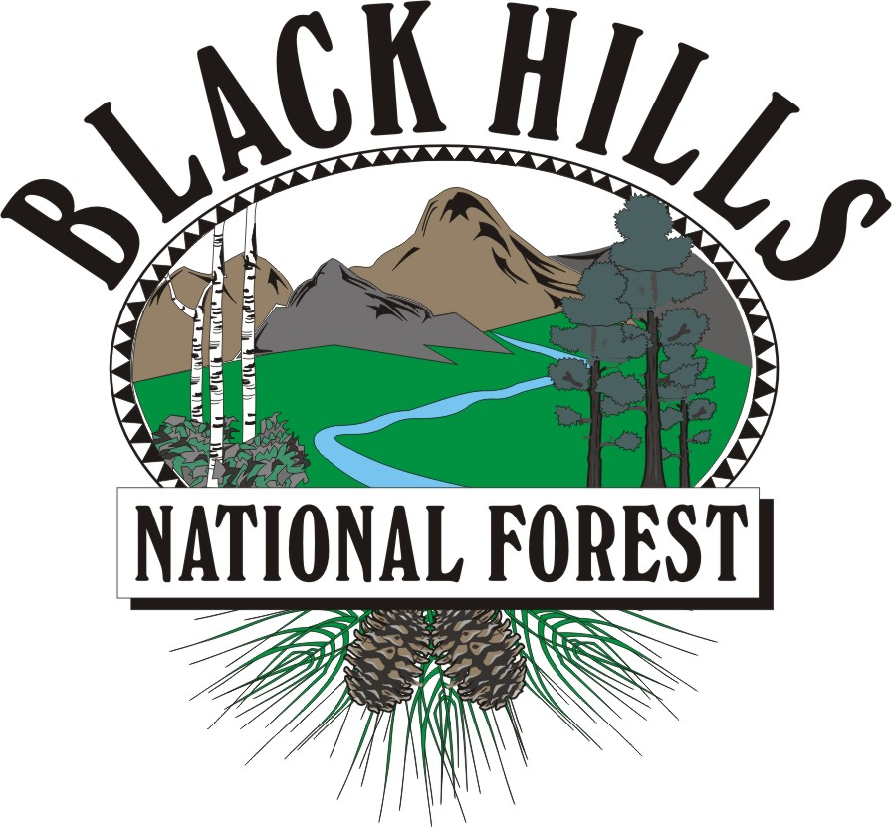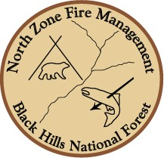**VACANCY ANNOUNCEMENT**

**BEARLODGE RANGER DISTRICT**

# Handcrew Squad Leader (Assistant Handcrew Captain)

**OCRP-HANDCREW-462-6DP (Demo)**

**OCRP-HANDCREW-462-6G (Merit)**

**GS-0462-06**

**13/13**

# Engine Squad Leader (Assistant Engine Captain)

**OCRP-AFEO-462-6DP (Demo)**

**OCRP-AFEO-462-6G (Merit)**

**GS-0462-06**

**13/13**

|  |
| --- |
| Submit Application in AVUE By: 02/14/2011 |

The Black Hills National Forest is recruiting to fill one Handcrew Squad Leader (Assistant Handcrew Captain) and one Engine Squad Leader (Assistant Engine Captain) at the GS-0462-06 level with a duty location of Sundance, Wyoming (Bearlodge Ranger District). These are both permanent seasonal 13/13 positions. Permanent seasonal 13/13 appointments are described as appointments where the incumbent is guaranteed work for at least 13 pay periods and may be in a non-pay status for up to 13 pay periods of the year. Vacancy will be filled under the open continuous announcements posted on Avue Digital Service. A referral list will be requested under the USDA Demonstration Project (Demo), and the Merit promotion program, through Albuquerque Service Center.

The application process will be through Avue Digital Services:

**Vacancy announcements #:**

**OCRP-HANDCREW-462-6DP and OCRP-HANDCREW-462-6G**

**OCRP-AFEO-462-6DP and OCRP-AFEO-462-6G**

**Duty Location: Sundance, WY (Bearlodge Ranger District)**

Applicants MUST apply accordingly, have an active application in Avue Digital Services and also meet basic qualifications and selective factors (if applicable). Meeting the quality group is strictly in the applicant’s hands. A referral list will be pulled on or soon after **02/28/2011**.

**ABOUT THE POSITION**

The Handcrew position will include performing wildland fire fighting duties and serving as the assistant supervisor of an eight to ten person Initial Attack fire suppression module. The incumbent will be supervised by the Handcrew Captain and will be responsible for fireline, project, and general work supervision in the absence of the Handcrew Captain. The Engine position will include performing wildland fire fighting duties and serving as the assistant supervisor of a Type 6 wildland engine with up to two other crew members. The incumbent will be supervised by an Engine Captain with collateral responsibilities in pump and apparatus maintenance, in addition to fireline, project, and general work supervision in the absence of the Engine Captain. The target Wildland Fire Qualifications of these positions is ICT5 and FFT1. Duties assigned to the incumbent may include (but are not limited to):

* Administrative tasks such as inputting time and travel vouchers for crewmembers.
* Providing supervision for firefighters on local fire assignments, and off-forest details.
* Conducting and/or assisting with formal and informal training of firefighters.
* Actively participating in the district Physical Fitness program, and leading by example.

While not performing suppression and prescribed fire activities, the incumbent may be assigned to other resource management activities such as hazardous fuels reduction, brush disposal, recreation, range, wildlife, or timber. Incumbent is required to complete a Health Screening Questionnaire (HSQ) and/or a physical examination prior to taking the Work Capacity Test (WCT). Based on the type of work performed, TAKING and PASSING the Work Capacity Test (WCT) at the ARDUOUS level is a condition of employment.

We are seeking a high-quality individual, with a diverse background and experience, to participate in the professional growth of the North Zone program.

Some of the experiences, knowledge, skills and abilities that we look for in people are;

* **Strong, diverse experience in wildland fire fighting techniques and tactics, such as Engine, Handcrew, Helitack and Fuels**
* **High level of physical fitness**
* **Good written and oral communication skills**
* **A positive attitude towards the work environment and fellow crew members**
* **A safe and professional working attitude**
* **Ability to work effectively within a zone organization**
* **Leadership abilities and team building**
* **A strong work ethic**
* **Forestry background**

**ABOUT THE ZONE**

This position is located on the Bearlodge Ranger district, within the North Zone of the Black Hills National Forest. The North Zone Fire Management program includes the Northern Hills Ranger District located in Spearfish, SD and the Bearlodge Ranger District located in Sundance, WY. The North Zone hosts 2 Type VI Engines, 1 Type III Engine, and 1 Type IV Engine, 2 five person fuels modules, 1 prevention module and 2 10-person initial attack hand crews.

The North Zone of the Black Hills N.F. averages approximately 60 ignitions per year. The fire management program on the Black Hills National Forest is one of the largest in the Rocky Mountain region and includes: an average of 180 ignitions per year (in short return interval ponderosa pine), and staffs approximately 20 Type VI Engines, 3 Type IV Engines, 3 Type III Engines, an exclusive use Type III helicopter, an Interagency Hotshot Crew, a national air tanker contract and an interagency dispatch center.

Additional information can be obtained about North Zone Fire at the unofficial website:

<http://www.northzonefire.com>

**BLACK HILLS NATIONAL FOREST**

The Black Hills National Forest is 1.2 million acres of forested hills and mountains. It is 110 miles long and 70 miles wide, approximately 87 percent of which are in South Dakota and 13 percent in Wyoming. Some unique features in the area include Devils Tower National Monument, Mount Rushmore National Monument, Crazy Horse Mountain, Wind Cave National Park, Jewel Cave National Monument, Badlands National Park and Custer State Park.

**BEARLODGE RANGER DISTRICT**

The Bearlodge District totals about 200,000 acres in the northern part of the Black Hills within the State of Wyoming. Timber harvest and related silvicultural activity is the largest resource program on the district. Average annual timber offer is about 10 million board feet. The district also has very active programs in lands and minerals, wildlife habitat improvement, recreation, cultural resources, and livestock grazing. Game species on the district include white-tailed and mule deer, Rocky Mountain elk, Merriam’s turkey and Ruffed grouse.

**SUNDANCE COMMUNITY**

The Bearlodge Ranger District has an office on the eastern edge of Sundance, Wyoming, which has a population of approximately 1,200.

Sundance is located 30 miles west of Spearfish, SD, and 74 miles northwest of Rapid City, SD, 365 miles north of Denver, Colorado, 542 miles west of Minneapolis and 200 miles northeast of Casper, Wyoming. The elevation of Sundance is 4,753 feet above sea level.

The town of Sundance is a scenic community with moderate temperatures. The average annual mean temperature is 43.6 degrees with the average January temperature 19.1 degrees and July's average of 69.8 degrees. The annual average rainfall is 9.0 inches and annual snowfall is 77 inches. Prevailing winds are from the northwest.

The community of Sundance offers one library, two day care centers, ten churches, four motels, one RV park, one hospital, a nursing home, one dentist, three doctors, one newspaper, one bank, cable television, post office, telephone service, telegraph, police department, volunteer fire department, emergency medical technicians, city offices, as well as some local retail businesses. The nearest airport is Black Hills Airport four miles east of Spearfish and other commercial airline services are available at Gillette, WY and Rapid City, SD.

Public recreation in Sundance include one baseball field, one golf course, two tennis courts, one bike path, one swimming pool, and two parks. In the immediate vicinity is trout fishing, access to over 300 miles of snowmobile trails, hunting, hiking and camping. Forest service campgrounds near Sundance are Cook Lake, Reuter, and Sundance Trailhead. Devils Tower National Monument, America’s first National Monument, is located 27 miles northwest of Sundance. There is a Wyoming State Park at Keyhole Reservoir 19 miles west on Interstate 90.

Other area recreation facilities and attractions available are the: Crook County Museum, Crook County Art Gallery, Ranch A, D.C. Booth Historical Fish Hatchery, Matthew's Opera House, Thoen Stone Monument, High Plains Heritage Center; Donald E. Young Sports and Fitness Center-BHSU; Bear Butte State Park, Spearfish Canyon Scenic Byway, and downhill and cross country skiing.

Major employers in Sundance are: Crook County School District, US Government agencies, Powder River Electric (REA), Crook County Nursing Home, Energy Electric (construction), and Wyoming Transportation Department.

Other major employers within commuting distance include Black Hills State University, Pope and Talbot, Inc., Neiman Sawmill, Black Hills Power and Light, various mining companies, including and a variety of service jobs in the tourism industry.

Rental homes are scarce in Sundance, rent ranges from $500-700/month for an average three bedroom home. There are a limited number of homes for sale in the $85,000 to $150,000 range. There is some housing available in Upton, WY located 30 miles southwest of Sundance.

Sundance has a public school district with one elementary school, one junior high and one high school and a Community Education Program. Black Hills State University at Spearfish, SD, and offers both day and night classes.

The Sundance area is a thriving community with recreational opportunities unending. It is truly a great place to live! Property taxes in Wyoming are very reasonable; the property taxes in South Dakota are considerably higher.

If you would enjoy working as part of the North Zone Fire Management Organization on the Black Hills National Forest, we encourage you to apply for these positions. If you would like more information about these positions, please contact Trevor Papenfuss, Shane Phillips or Don Doten.

CONTACTS:

Trevor Papenfuss – Bearlodge Fire Operations Supervisor

[tpapenfuss@fs.fed.us](mailto:tpapenfuss@fs.fed.us)

Phone: 307-283-1361

Shane Phillips – Bearlodge Engine Captain

[shanephillips@fs.fed.us](mailto:shanephillips@fs.fed.us)

Phone: 307-290-0883

Don Doten – Bearlodge Handcrew Captain

[ddoten@fs.fed.us](mailto:ddoten@fs.fed.us)

Phone: 307-290-0884